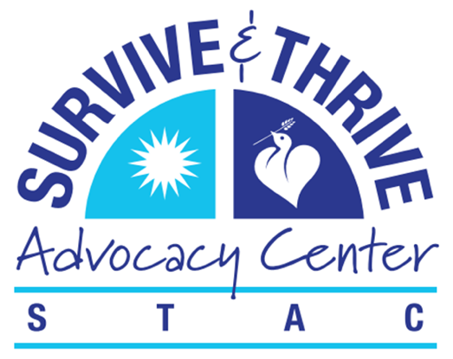
Imagining Freedom
ONLINE!
Featuring Chef Art Smith

Preprogram starts at 11:15 a.m.
Program starts at Noon and ends at 1 p.m.
Thursday, Sept. 10, 2020

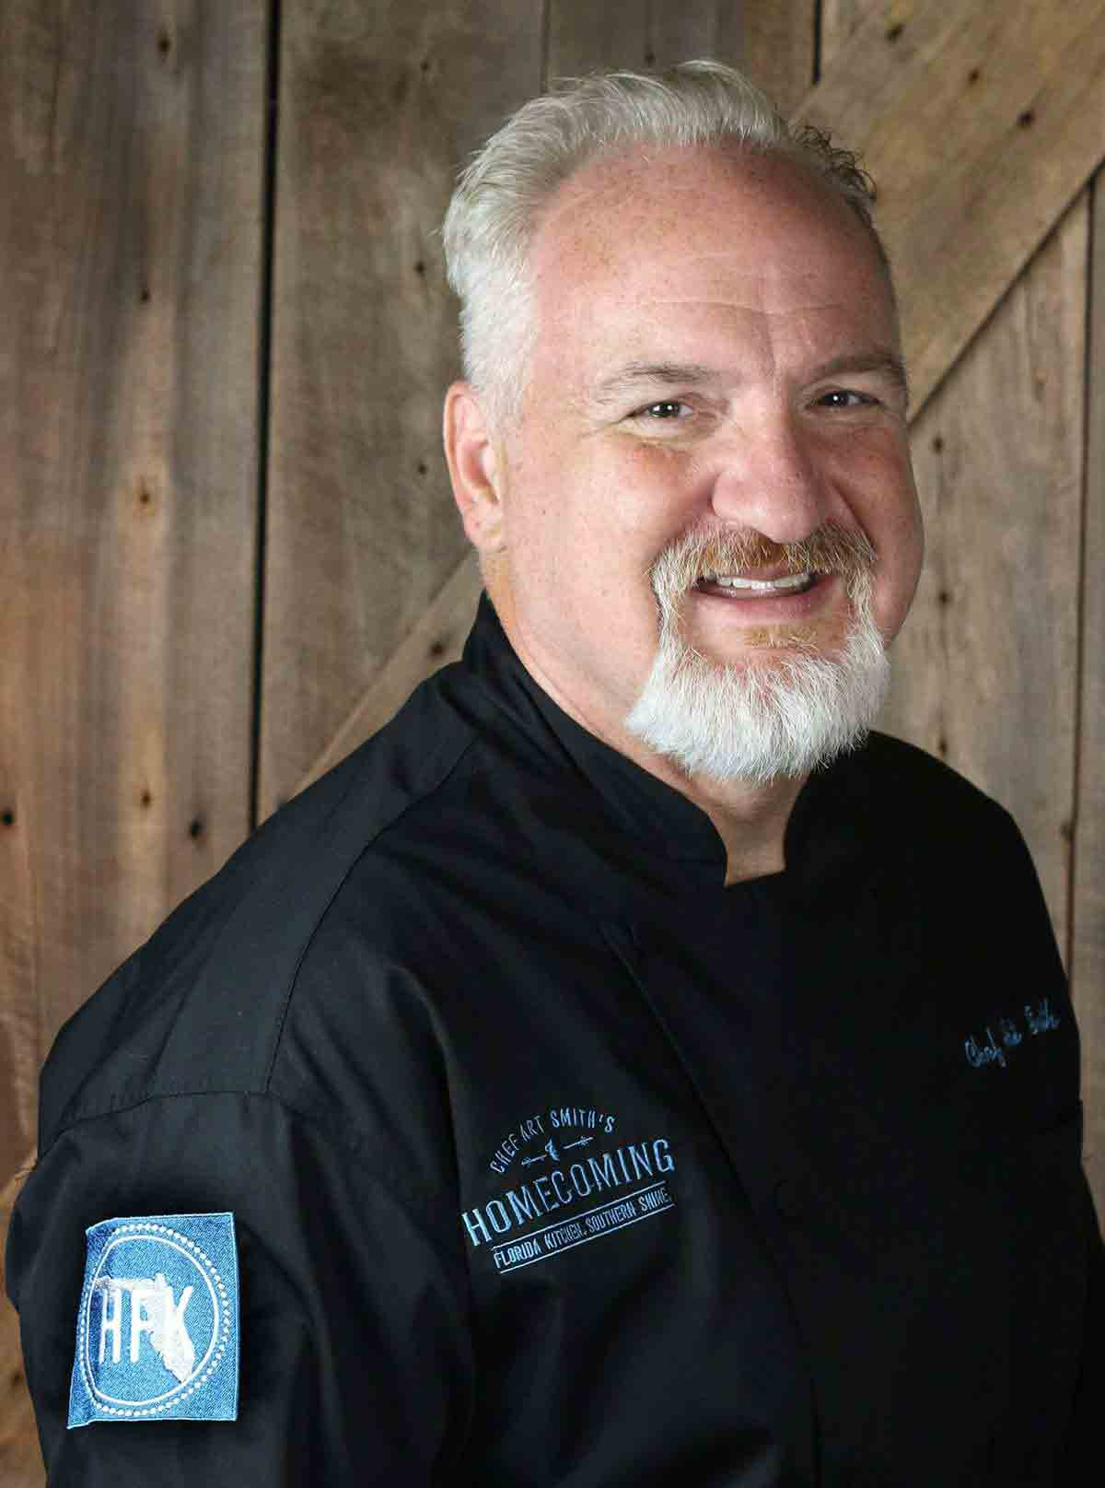
Join STAC and Chef Art Smith for:
Imagining Freedom – Online!
A Celebration of Trafficking-Free Foods

BECOME A SPONSOR!

This fun and informative program begins at noon on Thursday, Sept. 10, and includes a cooking demonstration by renowned Chef Art Smith, a Jasper, Florida, native. Chef Art is a familiar face on the national food scene with restaurants in several major cities and his Homecomin’ restaurant in Disney Springs in Orlando.
A sixth-generation Floridian, Chef Art was Oprah Winfrey’s personal chef for 10 years and cooked for two Florida governors in Tallahassee.
In addition to Chef Art, Imagining Freedom – Online! will include a celebration of the Red Hills Small Farm Alliance, which recently adopted a statement against trafficking and is informing all of its farmers and producers about the issue.
Proceeds from Imagining Freedom support STAC services and programs.
A member of the National Human Trafficking Hotline, STAC provides support to survivors of sex and labor trafficking of all ages and teaches people throughout our region how to recognize, report and prevent trafficking.
Your sponsorship helps make this work possible. Will you help keep these programs and services going by sponsoring Imagining Freedom?
If you have any questions, please contact Robin Hassler Thompson, STAC executive director, at robin@surviveandthriveadvocacy.org or 850-597-2080. THANK YOU for supporting human trafficking survivors and those who are vulnerable in the Big Bend!

Please see sponsorship opportunities on next page.
2020 Sponsorship Opportunities

Imagining Freedom – ONLINE!
Featuring Chef Art Smith
Preprogram starts at 11:15 a.m.
Program starts at Noon
Thursday, Sept. 10, 2020

Freedom & Justice Sponsor - $25,000
- Top logo placement in all promotions before and after the event
- Logo and quote included in the Imagining Freedom news release
- Top logo placement with link on the STAC website
- Logo and name used in social media posts before and after the event
- Top logo placement in the Imagining Freedom preview video
- Logo with link in email newsletters to 2,500+ subscribers
- Logo and full page of content in the event program
- Logo in video played during the event for 500+ attendees
- Opportunity to teleconference with STAC on media interviews
- Opportunity to participate in a Facebook Live video with STAC
- Opportunity to provide pre-recorded remarks for the event
- Two signed cookbooks from Chef Art Smith
- Basket of gourmet trafficking-free foods and recipes curated by Chef Art Smith and Food Glorious Food

Triumph Sponsor - $10,000
- Logo placement with link on the STAC website
- Logo and name used in social media posts before and after the event
- Logo placement in the Imagining Freedom preview video
- Logo in email newsletters to 2,500+ subscribers
- Logo and full page of content in the event program
- Logo included in video played during the event for 500+ attendees
- Recognition during the event
- Two signed cookbooks from Chef Art Smith
- Basket of gourmet trafficking-free foods and recipes curated by Chef Art Smith and Food Glorious Food

Liberation Sponsor - $5,000
- Logo placement on the STAC website
- Logo and name used in social media posts before and after the event
- Logo and half page of content in the event program
- Logo included in video presentation played during event for 500+ attendees
- Recognition during the event
- Two signed cookbooks from Chef Art Smith
- Basket of gourmet trafficking-free foods and recipes curated by Chef Art Smith and Food Glorious Food

Dignity Sponsor - $2,500
- Logo placement on the STAC website
- Logo and name used in social media posts before and after the event
- Logo and quarter page of content in the event program
- Logo included in video played during the event for 500+ attendees
- Signed cookbook from Chef Art Smith
- Basket of gourmet trafficking-free foods and recipes curated by Chef Art Smith and Food Glorious Food

Solidarity Sponsor - $1,000
- Name used in social media posts before and after the event
- Logo and name included in the event program
- Logo included in video played during the event for 500+ attendees
- Signed cookbook from Chef Art Smith
- Dessert basket of gourmet trafficking-free treats and recipes from Food Glorious Food

Hope Sponsor - $500
- Name used in social media posts before and after the event
- Name listed in the event program
- Logo included in video played during the event for 500+ attendees
- Signed cookbook from Chef Art Smith

Freedom Sponsor - $75
- Name used in social media posts and
- Name listed in the event program
- Chance to win a basket of gourmet trafficking-free foods, wine and recipes curated by Chef Art Smith and Food Glorious Food

2020 Sponsorship Commitment Form

Imagining Freedom – ONLINE! Featuring Chef Art Smith
Preprogram starts at 11:15 a.m.
Program starts at Noon and ends at 1 p.m.
Thursday, Sept. 10, 2020

Individual, Business or Organization Name: __________________________________________

Contact Name: ______________________________ Title: ______________________________

Address: ______________________________________________________________________

City: __________________________ State: ________________ Zip: ______________________

Email: __________________________ Sponsorship Level: ______________________________

Additional Notes/Comments and Ticket Orders: ______________________________________
____________________________________________________________________________________________________________________________________________________________

Payment Options
____Check Enclosed
Please mail this completed form, along with your check, to:
STAC
P.O. Box 13898
Tallahassee, FL 32317

____Credit Card
*To pay by credit card, please visit https://www.surviveandthriveadvocacy.org/campaigns/imaginingfreedom2020/

Thank you for supporting human trafficking survivors in the Big Bend and for helping STAC to provide education throughout our region. If you have any questions, please contact Robin Hassler Thompson, STAC executive director, at robin@surviveandthriveadvocacy.org or 850-597-2080.

The Survive and Thrive Advocacy Center, Inc. (STAC) is a tax-exempt organization as defined within the Internal Revenue Code Section, paragraph and subparagraph 501(c)3. As such, contributions made to the organization are generally considered deductible in full to the extent allowed by tax law. We suggest that you consult your tax advisor if you have questions on the deductibility of this or any contribution.
THE SURVIVE AND THRIVE ADVOCACY CENTER, INC. IS REGISTERED WITH THE FLORIDA DEPARTMENT OF AGRICULTURE AND CONSUMER SERVICES AS A CHARITY TO SOLICIT AND COLLECT CONTRIBUTIONS WITHIN THE STATE. OUR REGISTRATION NUMBER IS CH49747. A COPY OF THE OFFICIAL REGISTRATION AND FINANCIAL INFORMATION MAY BE OBTAINED FROM THE DIVISION OF CONSUMER SERVICES BY CALLING TOLL-FREE WITHIN THE STATE (800-435-7352). REGISTRATION DOES NOT IMPLY ENDORSEMENT, APPROVAL, OR RECOMMENDATION BY THE STATE.
Thank You to Our 2019 Sponsors
Liberation Sponsor
Featuring
Susan Levin Turner & Food Glorious Food
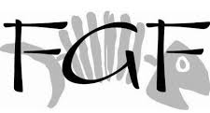

319 Wine and Cheese, Artistic Confections, Backwoods Bistro, Backwoods Crossing, Browns Produce Farms, Bumpy Road Farm, Crooked Row Farm, Cypress Restaurant, Deep Brewing Co., Desserts By Latrell, Dreamland BBQ, Full Earth Farm, Gaines Street Pies, Glendower Farms, Handsome Harvest Farm, La Tiendita Mexican Restaurant, Lucy and Leo’s Cupcakery, Longview Farms, Madison Social, Oyster Mom, Ragged, Glory Farm, RedEye Coffee, Shirley Girl Cheese, Southern Seafood Inc., SoDough Baking Co., The Fresh Market, Turkey Hill Farm, Uptown Café and Catering, Willie Jewell’s Bar-B-Que

Quincie Hamby Art Jewelry
RedEyeCoffee
Soul Fabric
Ten Thousand Villages
Threads Worldwide/
Michelle Hawken
Menia Chester/Desserts By Latrell

Providing Volunteers
Florida Council on Crime and Delinquency
FSU Center for the Advancement of Human Rights
Zonta Club of Tallahassee

Decorations
Cricket Mannheimer
Quincie Hamby

Photography
Riko Carrion

Musicians
Elio Delgado; Molly McQueeney; Emily Offenkrantz

Marketing and Communications
Rebeccah Lutz Content Strategy, LLC

Food

Solidarity Sponsors
Robin Hassler Thompson & Dan Thompson
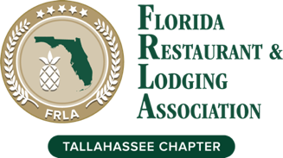
The Marketplace

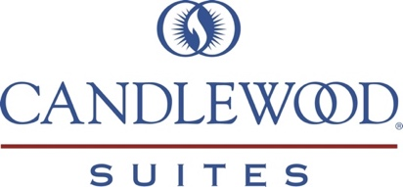

Hope Sponsors
BB&T Scott & Stringfellow
Baker, Donelson, Bearman, Caldwell & Berkowitz
Susan Bowers
Berger Singerman, LLP
Big Bend Children’s Home Society
Florida Medical Association
Florida Restaurant & Lodging Association
Judy A. Gagnon, RMR, FCRR
Christin Foster Gonzalez
North Florida Animal Hospital
PACE Center for Girls Leon
Anne and Colin Phipps
Mary Anne Price
Radey Attorneys & Counselors at Law
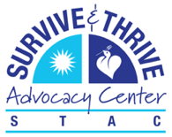
Tallahassee Women Lawyers
Kathy Villacorta and Tommy Warren

